Press release 25th October 2007

Eat Drink Design
Dutch design and culinary expertise come together
during the Dutch Design Week

Kiki van Eijk and restaurant De Karpendonkse Hoeve in Eindhoven will be a temporary couple. Just as Dick van Hoff and restaurant Osteria. During the Dutch Design Week, from 20th to 28th October, they and six other pairs of chefs and designers will present the results of their brief collaboration during the exclusive Dutch Design Dinner.

Eat Drink Design, an initiative by design studio Moon/en/co and the culinary phenomenon Sot-l’y-laisse, coupled eight designers to eight top-class restaurants in and around Eindhoven. During the Dutch Design Week, each one of these pairs will present the results of their collaboration: a fusion of Dutch design and culinary expertise. This will take place in the eight participating restaurants and, in particular, in a temporary restaurant and exhibition venue decorated with work by Dutch designers and which was opened especially for the Dutch Design Week.

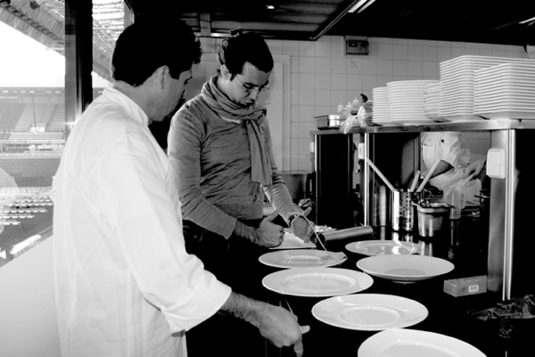
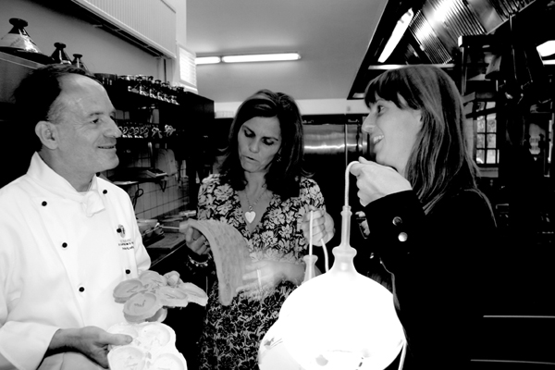

Left: Maarten Baptist (r) presents a sketch to patron-cuisinier Johan van Groeninge
Right: Kiki van Eijk (r) presents her bottled lamp to Master Chef Peter Koehn and Ingrid van Eeghem

The added value of the creative industries
Point of departure for the project is the added value that the creative industries can bring to other sectors - in this case, to the restaurant sector. This is why design solutions were explored for situations that both the staff and the restaurants have to cope with in their daily work. These collaborative efforts resulted in a unique experience of food and design: where the chef provides the inspiration for the designer and vice versa.

From oven mitts to cookers
The collaboration provided a diversity of results. For example: Dick van Hoff designed a robust outdoor cooker for restaurant Osteria, which can be used to create a fantastic dinner with little more than fire, steel and high-quality ingredients. To protect the hands of the waiters and waitresses at Restaurant 1910 against the heat of their plates, Carolien Niebling provided ergonomically designed heat-resistant mitts. Annelies Hermsen developed a line of packaging for Da Nello for their basic line of Italian delicatessen products, such as truffle butter and olive oil. For Groeninge’s restaurant, Avant Garde, Maarten Baptist designed an element fashioned out of laboratory glass that adds a drop of taste to the food at every bite. Kiki van Eijk interpreted the assignment illustratively and made image-determining lamps, inspired by hand-crafted medieval bottles. This idea was elaborated on by restaurant De Karpendonkse Hoeve, whose dishes also showed an illustrative character. Joost van Bleiswijk embroidered on the theme of his No glue, no screw series of furniture and developed a serving dish for Restaurant Zuid, while the restaurant served a dish called No glue, no screw. Kranen/Gille designed a serving trolley for De Lindehof, which serves as a champagne cooler at the beginning of the evening and as a cheeseboard at the end of the meal. This proved to be not only a good solution for a lack of space, but also a theatrical highlight at the table. For Hostellerie Vangaelen, Jens Praet transformed the traditional side table into a real multi-purpose eye-catcher.

Temporary restaurant with exhibition
At just a stone’s throw away from the Design Academy Eindhoven, the heart of the Dutch Design Week, Eat Drink Design opened a temporary restaurant with exhibition space. A 200–square-metre glasshouse, specially designed for the event, functions as the meeting place for both lovers of design and fine food. During the day, visitors can not only feast their palates on truffles and coffee or oysters and champagne, but can also feast their eyes on a venue completely decorated by Dutch designers. In the evening an exclusive Dutch Design Dinner can be enjoyed, served by a different top-class chef every day.

Eat Drink Design last year
During the Dutch Design Week 2006, the premiere edition of this project took place: for ten days, guests were able to enjoy food, drink and the exclusive Dutch Design Dinner as well as the work of both new and established design talents in an informal atmosphere. A culinary experience with paying guests volunteering to do the dishes in stocking feet, and - on average - cries of delight emanating from the kitchen after every third dish. For this second edition, Annemoon Geurts, Koen Rijnbeek and Edwin Severijn have taken it one step further. By initiating and facilitating creative impulses, they have been able to showcase themselves as catalysts of industry. Inspiring people, making them enthusiastic and stimulating them is their main goal and, at the same time, proving the added value of the creative industries to other sectors.

For more information and reservations: +31 (0)40 2366196 & www.eatdrinkdesign.nl

Eat Drink Design is sponsored by Design Connection Eindhoven Region and the Municipality of Eindhoven.

Note for the editor:
For more information, visual materials or interview requests please contact: Annemoon Geurts (Moon/en/co): +31 (0)40 2364351 / +31 (0)6 22529413 / studio@moonenco.nl or Edwin Severijn (Sot-l’y-laisse): +31 (0)6 53644438 / sotlylaisse@planet.nl

Visual materials
Texts and images about the event, the exhibition and the chef/designer project will be available on www.eatdrinkdesign.nl/pers. During this week, we will regularly be publishing reports about the designs presented by the couples including visual materials.

EAT DRINK DESIGN @ DUTCH DESIGN WEEK
The greenhouse on the Lichtplein in Eindhoven
Behind Design Academy
20th - 28th October 2007

Exhibition, espresso & lunch 12:00 - 15:00
Exhibition, bubbles & oysters 15:00 - 17:30
Dutch Design Dinner 19:00 - 00:00

There are still some seats available at the Dutch Design Diner. The programme lasts all evening and the price of € 110 will include an aperitif, accompanying wines and coffee. Due to the limited number of seats we recommend booking in advance: +31(0)40 23 66 196
info@eatdrinkdesign.nl www.eatdrinkdesign.nl

EAT & DRINK / Restaurant 1910 / Avant Garde van Groeninge / De Karpendonkse Hoeve / De Lindehof / Da Nello / Osteria / Sot-l’y-laisse / Hostellerie Vangaelen / Restaurant Zuid

DESIGN / Maarten Baptist / Joost van Bleiswijk / BLOKmeubel / d’Andt / Kiki van Eijk / Lonneke Gordijn / Annelies Hermsen / Dick van Hoff / Kranen & Gille / Sander Lucas / Carolien Niebling / Fenna Oosterhoff / Jens Praet / Mara Skujeniece / Iris Tonies / Anke Weiss

PROGRAMM
SOT-L’Y-LAISSE / ANNELIES HERMSEN
Daily Lunch

RESTAURANT ZUID / JOOST VAN BLEISWIJK
Saturday evening 20. October

AVANT GARDE / MAARTEN BAPTIST
Sunday evening 21. October (sold out)

RESTAURANT 1910 / CAROLIEN NIEBLING
Monday evening 22. October (sold out)

DE LINDEHOF / KRANEN & GILLE
Tuesday evening 23. October

DE KARPENDONKSE HOEVE / KIKI VAN EIJK
Wednesday evening 24. October

OSTERIA / DICK VAN HOFF
Thursday evening 25. October

HOSTELLERIE VANGAELEN / JENS PRAET
Friday evening 26. October

SOT-L’Y-LAISSE / EDD 2006 REVISITED
Saturday evening 27. October (sold out)

RISTORANTE DA NELLO / ANNELIES HERMSEN
Sunday evening 28. October

Eight designers and eight chefs collaborated as a pair to attain unique products that can be used by these restaurants in their daily work. The designers were inspired by the chefs and vice versa. During Eat Drink DESIGN, these couples will present the results of their collaboration: a fusion of Dutch design and culinary expertise.

Point of departure for the project is the added value that the creative industries can bring to other sectors of industry - in this case, to eight top-class restaurants in and around Eindhoven. Design solutions were explored for situations that both the staff and the restaurants have to cope with in their daily work.

PROJECT RESULTS
Not a single screw or a drop of glue were used in the No glue, no screw series of furniture. Designer Joost van Bleiswijk embroidered on this concept and designed a serving dish for Restaurant Zuid, which inspired top chef Michiel Verbakel to serve a dish that was built up according to the same principles as No glue, no screw.

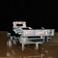
Joost van Bleiswijk / Serving Plate XC
http://www.eatdrinkdesign.nl/downloads/JoostVanBleiswijk.zip.zip

Patron Cuisinier Johan van Groeninge loves to be inspired by beautiful or unusual services. This is why Maarten Baptist designed a silver clamp especially for restaurant Avant Garde with a holder fashioned out of laboratory glass and which literarily adds taste to the food: one drop of an extra ingredient, to go with every bite of food.

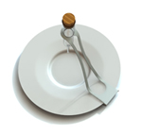
Maarten Baptist / Avant Garde standaard
http://www.eatdrinkdesign.nl/downloads/MaartenBaptist.zip

Serving plates that can be up to 140˚ Celsius requires sufficient protection and a good way to hold them. For Restaurant 1910, Carolien Niebling combined both of these aspects in an ergonomically designed oven mitt that can also be stuck to the oven or fridge with a magnet, as well as a special apron.

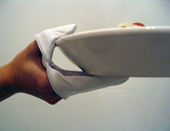
Carolien Niebling / Serve
http://www.eatdrinkdesign.nl/downloads/CarolienNiebling.zip

As a solution for lack of space - but more because of the theatrics it would present at table - Jos Kranen en Johannes Gille designed a wheeled champagne cooler for restaurant De Lindehof. At the end of the evening it can be transformed in no time at all into a cheeseboard by fitting it with a wooden platter.

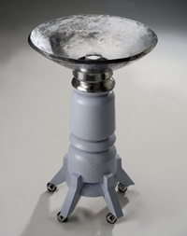

Kranen & Gille / Bubble Baptism
http://www.eatdrinkdesign.nl/downloads/KranenGille.zip

Kiki van Eijk became engrossed in the gastronomic culture and table settings of times gone by. Inspired by beautiful medieval hand-crafted bottles, she designed a carafe and a series of glass lamps for restaurant De Karpendonkse Hoeve as an illustrative addition to the restaurant. Master Chef Peter Koehn elaborated on this illustrative approach and conjured up a visual surprise dinner.
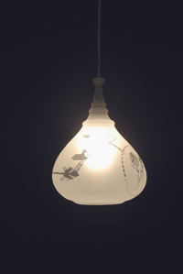

Kiki van Eijk / Bottled lamp
http://www.eatdrinkdesign.nl/downloads/KikiVanEijk.zip

Steel, fire, and ingredients. According to Dick van Hoff, nothing else is necessary for the preparation of an exquisite dinner. The robust outdoor kitchen he designed for the Italian restaurant Osteria draws attention to the pure experience of cooking as it is, and the enjoyment of cooking.

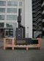
Dick van Hoff / Outside furnace
http://www.eatdrinkdesign.nl/downloads/JensPraet.zip

Although side tables do support an important function – somewhere to put down plates, or bottles of wine, for example – few restaurants pay any attention to them. For Hostellerie Vangaelen, Jens Praet transformed the traditional side table into a real multi-purpose eye-catcher.

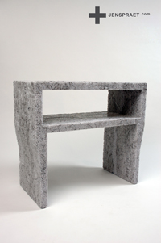

Jens Praet / One day paper waste sidetable
http://www.eatdrinkdesign.nl/downloads/JensPraet.zip

Annelies Hermsen developed a line of packaging for Ristorante De Nello for their basic line of Italian delicatessen products, such as truffle butter and olive oil, which was inspired by the ingredients themselves: tomatoes, eggplants and olives. The line of packaging is well-suited to the restaurant's style: authentic, sensible and sober.

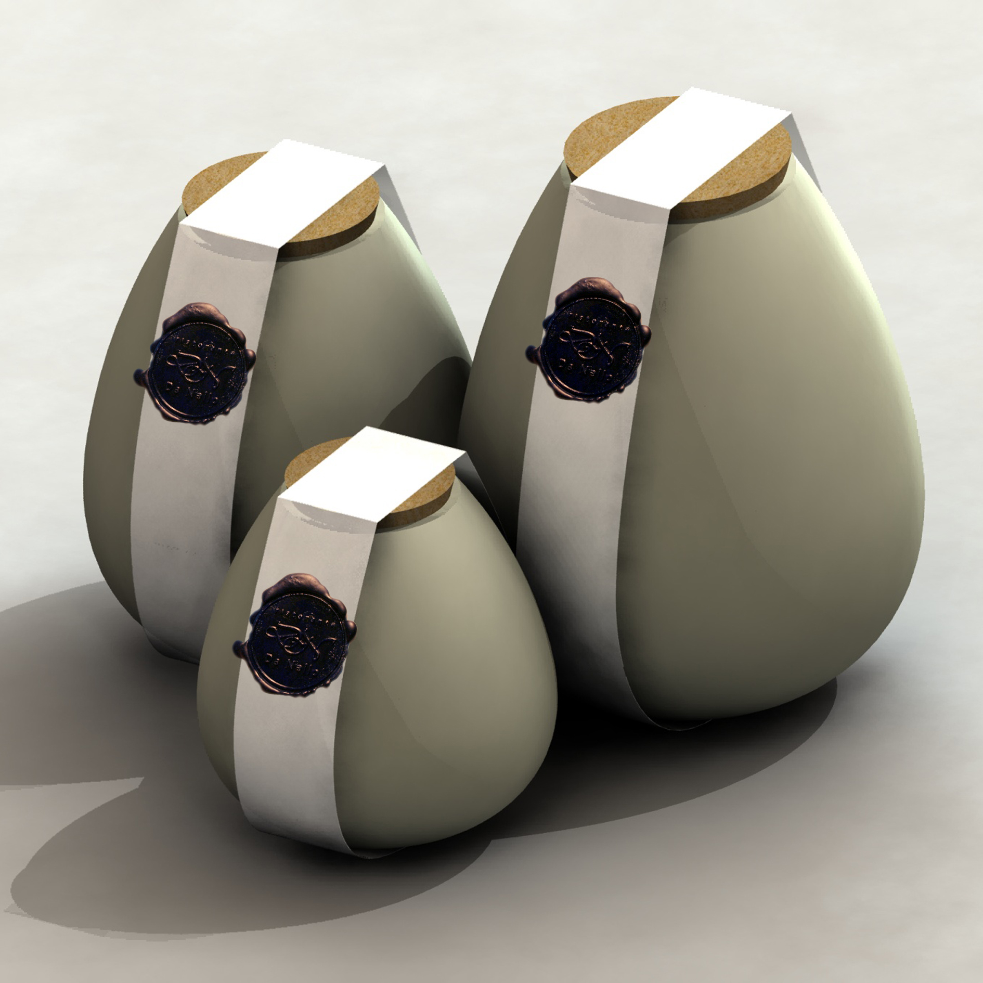
Annelies Hermsen/ verpakkingslijn DaNello
http://www.eatdrinkdesign.nl/downloads/AnneliesHermsen.zip

